Pausenareal Primar (12.20 – 13.10 Uhr)
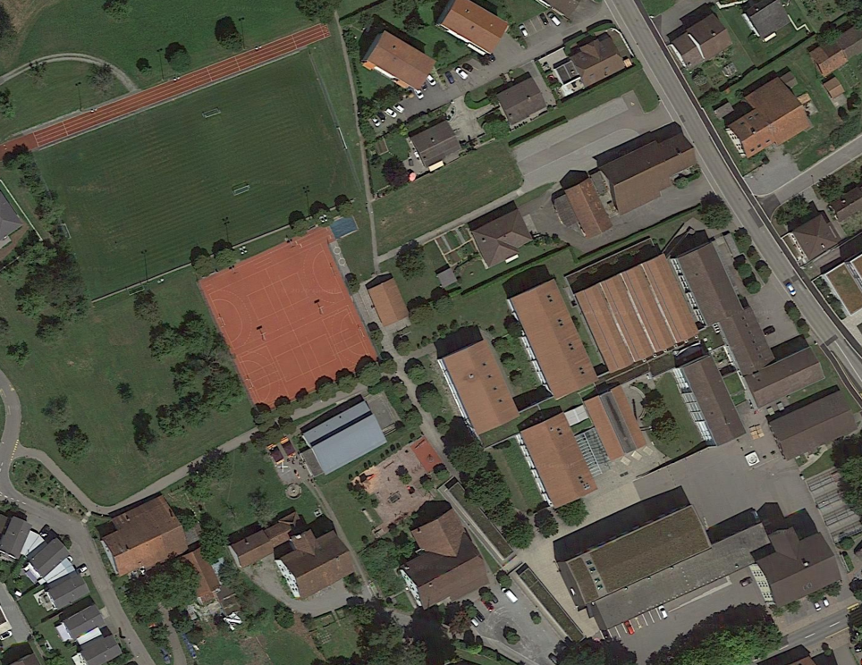
Aufsicht 1
Aufsicht 2
Aufsicht 3

